TASK 1

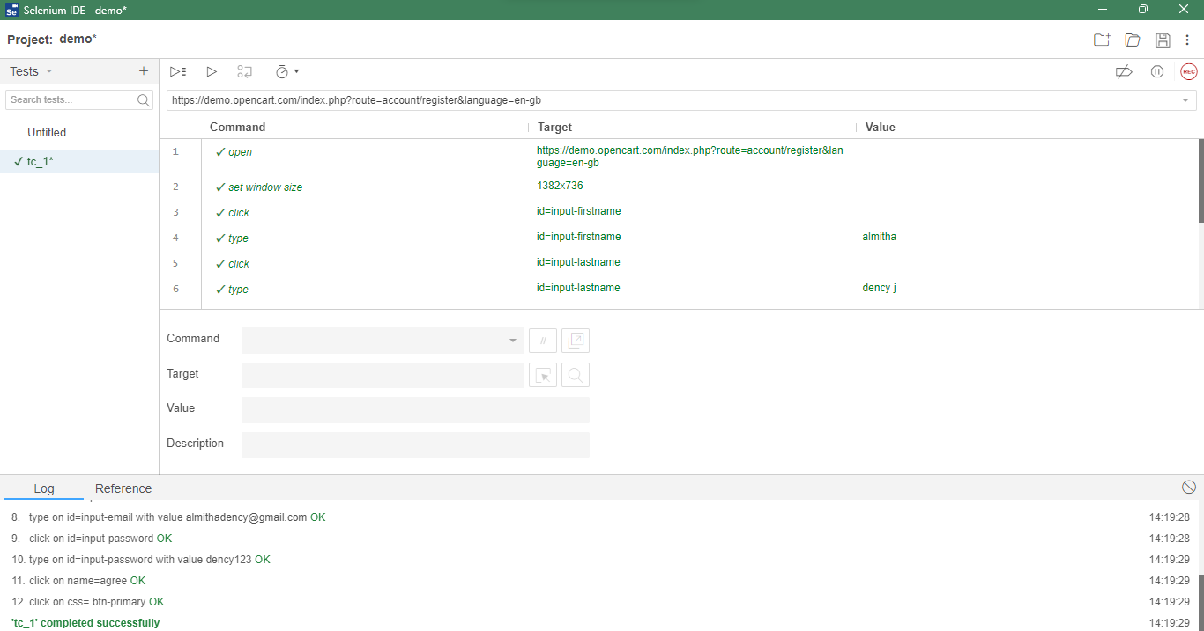

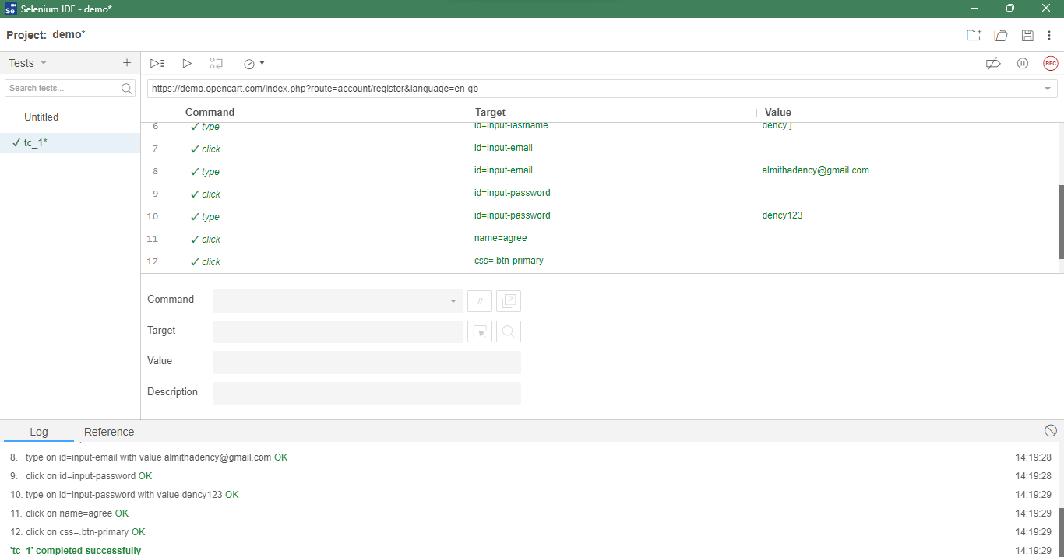

TASK 2

package com.selenium.test1.selenium1;

import org.openqa.selenium.By;

import org.openqa.selenium.WebDriver;

import org.openqa.selenium.WebElement;

import org.openqa.selenium.chrome.ChromeDriver;

import org.openqa.selenium.chrome.ChromeOptions;

import org.openqa.selenium.edge.EdgeDriver;

import io.github.bonigarcia.wdm.WebDriverManager;

/**

* Hello world!

*

*/

public class App

{

public static void main( String[] args )

{

// edge

// WebDriverManager.edgedriver().setup();

// WebDriver driver=new EdgeDriver();

// driver.get("https://google.com"); //open browser

//chrome

WebDriverManager.chromedriver().setup();

ChromeOptions co=new ChromeOptions();

co.addArguments("--remote-allow-origins=*");

WebDriver driver1=new ChromeDriver(co);

driver1.get("https://demo.opencart.com/index.php?route=account/register&language=en-gb"); //open browser

driver1.manage().window().maximize(); //mazimize the window

//driver1.findElement(By.className("gLFyf")).sendKeys("IT"); //search the content

//driver1.findElement(By.className("gNO89b")).submit(); //submits the search content

WebElement fn =driver1.findElement(By.id("input-firstname"));

System.out.println(fn);

WebElement ln =driver1.findElement(By.id("input-lastname"));

System.out.println(ln);

WebElement em =driver1.findElement(By.id("input-email"));

System.out.println(em);

WebElement pss =driver1.findElement(By.id("input-password"));

System.out.println(pss);

WebElement sub =driver1.findElement(By.id("input-newsletter-no"));

System.out.println(sub);

}

}

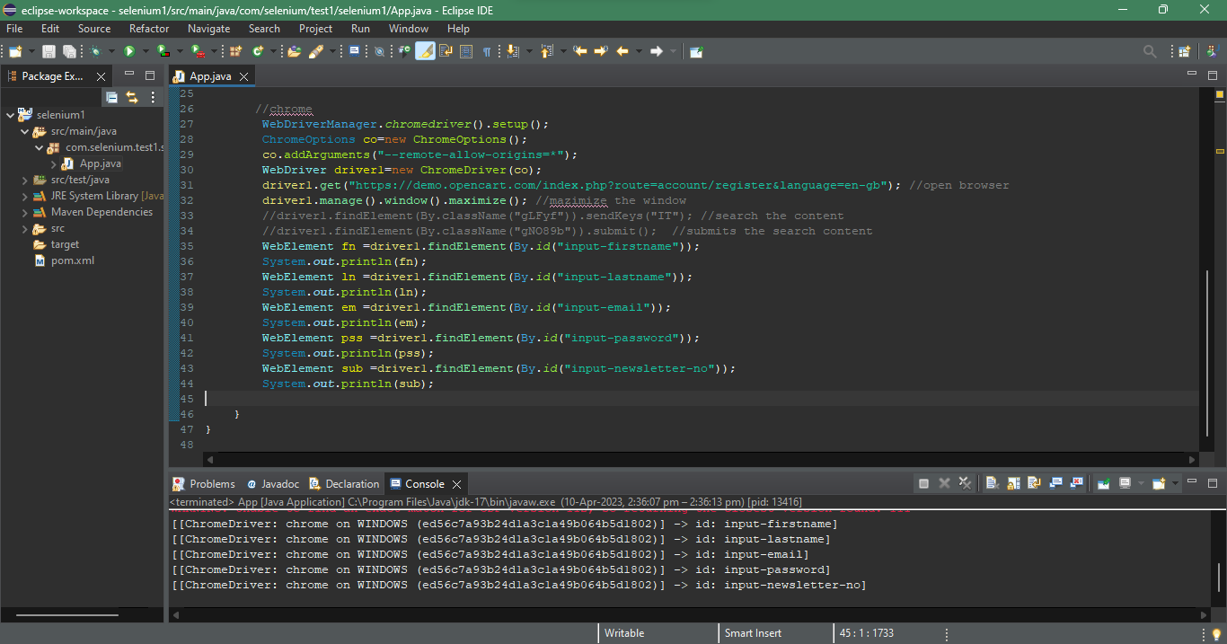

TASK 3

package com.selenium.test1.selenium1;

import org.openqa.selenium.By;

import org.openqa.selenium.WebDriver;

import org.openqa.selenium.WebElement;

import org.openqa.selenium.chrome.ChromeDriver;

import org.openqa.selenium.chrome.ChromeOptions;

import org.openqa.selenium.edge.EdgeDriver;

import io.github.bonigarcia.wdm.WebDriverManager;

/**

* Hello world!

*

*/

public class App

{

public static void main( String[] args )

{

// edge

// WebDriverManager.edgedriver().setup();

// WebDriver driver=new EdgeDriver();

// driver.get("https://google.com"); //open browser

//chrome

WebDriverManager.chromedriver().setup();

ChromeOptions co=new ChromeOptions();

co.addArguments("--remote-allow-origins=*");

WebDriver driver1=new ChromeDriver(co);

driver1.get("https://demo.opencart.com/index.php?route=checkout/voucher&language=en-gb"); //open browser

driver1.manage().window().maximize(); //mazimize the window

WebElement fn =driver1.findElement(By.xpath("//*[@id=\"input-to-name\"]"));

System.out.println(fn);

WebElement em =driver1.findElement(By.xpath("//*[@id=\"input-to-email\"]"));

System.out.println(em);

WebElement rn =driver1.findElement(By.xpath("//*[@id=\"input-from-name\"]"));

System.out.println(rn);

WebElement re =driver1.findElement(By.xpath("//*[@id=\"input-from-email\"]"));

System.out.println(re);

WebElement cer =driver1.findElement(By.xpath("//*[@id=\"input-theme-7\"]"));

System.out.println(cer);

WebElement mess =driver1.findElement(By.xpath("//*[@id=\"input-message\"]"));

System.out.println(mess);

WebElement cnt =driver1.findElement(By.xpath("//*[@id=\"input-amount\"]"));

System.out.println(cnt);

}

}

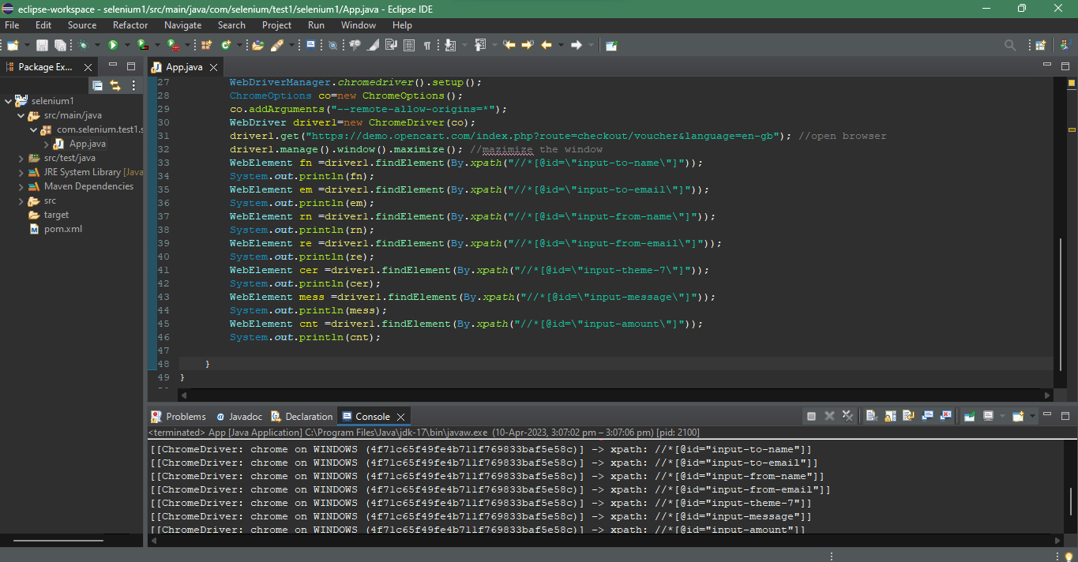

TASK 4

package com.selenium.test1.selenium1;

import org.openqa.selenium.By;

import org.openqa.selenium.JavascriptExecutor;

import org.openqa.selenium.WebDriver;

import org.openqa.selenium.WebElement;

import org.openqa.selenium.chrome.ChromeDriver;

import org.openqa.selenium.chrome.ChromeOptions;

import org.openqa.selenium.edge.EdgeDriver;

import io.github.bonigarcia.wdm.WebDriverManager;

/**

* Hello world!

*

*/

public class App

{

public static void main( String[] args )

{

// edge

// WebDriverManager.edgedriver().setup();

// WebDriver driver=new EdgeDriver();

// driver.get("https://google.com"); //open browser

//chrome

WebDriverManager.chromedriver().setup();

ChromeOptions co=new ChromeOptions();

co.addArguments("--remote-allow-origins=*");

WebDriver driver1=new ChromeDriver(co);

driver1.get("https://j2store.net/free/"); //open browser

driver1.manage().window().maximize(); //mazimize the window

JavascriptExecutor js=(JavascriptExecutor)driver1;

js.executeScript("window.scrollBy(0,1000)","");

driver1.findElement(By.linkText("Clothing (5)")).click();

driver1.navigate().back();

driver1.navigate().forward();

driver1.navigate().refresh();

driver1.quit();

}

}

TASK 5.1

package com.selenium.test1.selenium1;

import org.openqa.selenium.By;

import org.openqa.selenium.JavascriptExecutor;

import org.openqa.selenium.WebDriver;

import org.openqa.selenium.WebElement;

import org.openqa.selenium.chrome.ChromeDriver;

import org.openqa.selenium.chrome.ChromeOptions;

import org.openqa.selenium.edge.EdgeDriver;

import io.github.bonigarcia.wdm.WebDriverManager;

/**

 * Hello world!

 *

 */

public class App

{

    public static void main( String[] args )

    {

//      edge

//        WebDriverManager.edgedriver().setup();

//        WebDriver driver=new EdgeDriver();

//        driver.get("https://google.com"); //open browser

       //chrome

        WebDriverManager.chromedriver().setup();

        ChromeOptions co=new ChromeOptions();

        co.addArguments("--remote-allow-origins=*");

        WebDriver driver1=new ChromeDriver(co);

        driver1.get("https://j2store.net/free/"); //open browser

        driver1.manage().window().maximize(); //mazimize the window

        JavascriptExecutor js=(JavascriptExecutor)driver1;

        js.executeScript("window.scrollBy(0,1000)","");

        String url1="https://j2store.net/free/";

        String url2="";

        url2=driver1.getCurrentUrl();

        if(url1.equals(url2))

         System.out.println("Correct 1st page url");

        driver1.findElement(By.linkText("Clothing (5)")).click();

        url1=driver1.getCurrentUrl();

        if(url1.equals("https://j2store.net/free/index.php/shop?filter_catid=11"))

         System.out.println("Correct 2nd page url");

    }

}

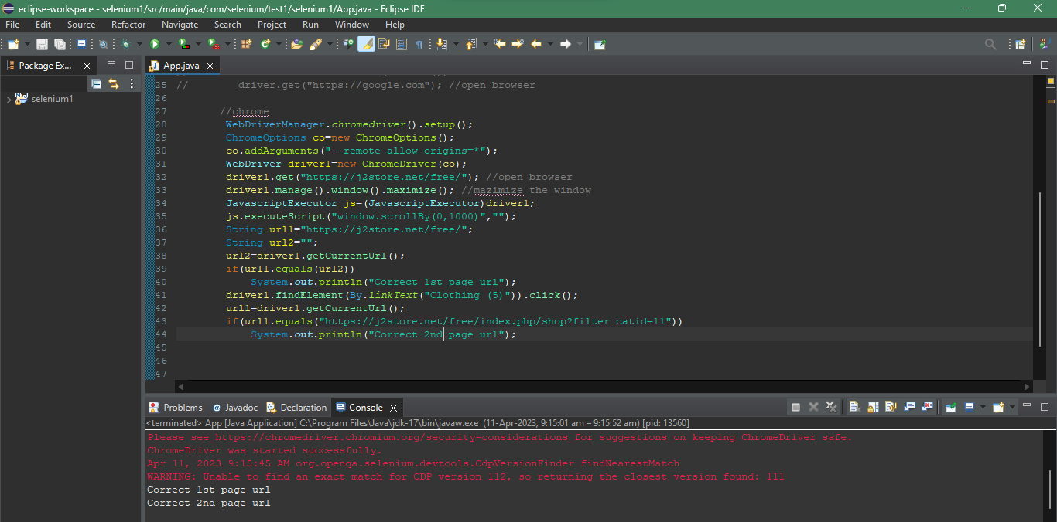

TASK 5.2

package com.selenium.test1.selenium1;

import java.util.List;

import org.openqa.selenium.By;

import org.openqa.selenium.JavascriptExecutor;

import org.openqa.selenium.WebDriver;

import org.openqa.selenium.WebElement;

import org.openqa.selenium.chrome.ChromeDriver;

import org.openqa.selenium.chrome.ChromeOptions;

import io.github.bonigarcia.wdm.WebDriverManager;

/**

* Hello world!

*

*/

public class App

{

public static void main( String[] args ) throws InterruptedException

{

// edge

// WebDriverManager.edgedriver().setup();

// WebDriver driver=new EdgeDriver();

// driver.get("https://google.com"); //open browser

//chrome

WebDriverManager.chromedriver().setup();

ChromeOptions co=new ChromeOptions();

co.addArguments("--remote-allow-origins=*");

WebDriver driver1=new ChromeDriver(co);

driver1.get("https://j2store.net/free/"); //open browser

driver1.manage().window().maximize(); //maximize the window

JavascriptExecutor js=(JavascriptExecutor)driver1;

js.executeScript("window.scrollBy(0,1000)","");

driver1.findElement(By.linkText("Clothing (5)")).click();

Thread.sleep(5000);

List<WebElement> l1=driver1.findElements(By .xpath("//h2[@class='product-title']"));

for(WebElement link:l1)

{

System.out.println(link.getText());

}

}

}

